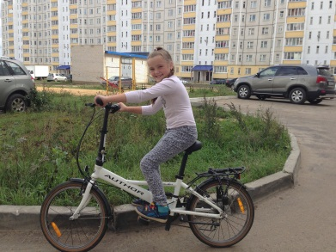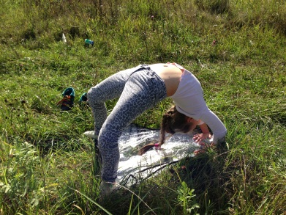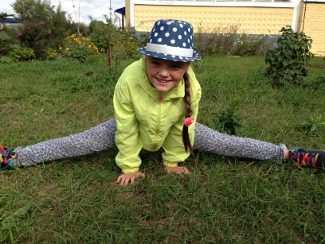

Конкурсная работа

*Сорокина София, 3 класс,*

*МБОУ - лицей № 4 имени Героя Советского Союза Г. Б. Злотина города Орла.*

*Учитель: Горинова Светлана Александровна*



***"Summer – The Best Time for Sport"***



Summer is the best time for sport. We can do some sports everywhere! It’s fantastic!

DOING SPORTS NEAR THE HOUSE

It is great to go in for sports in a playground near the house! But mind, your parents are watching you! Don’t do silly things!

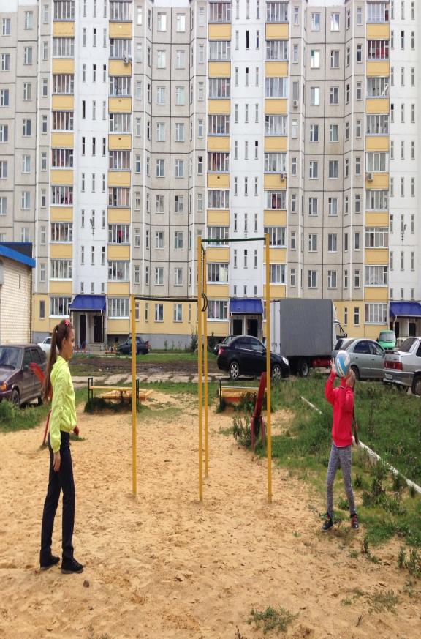

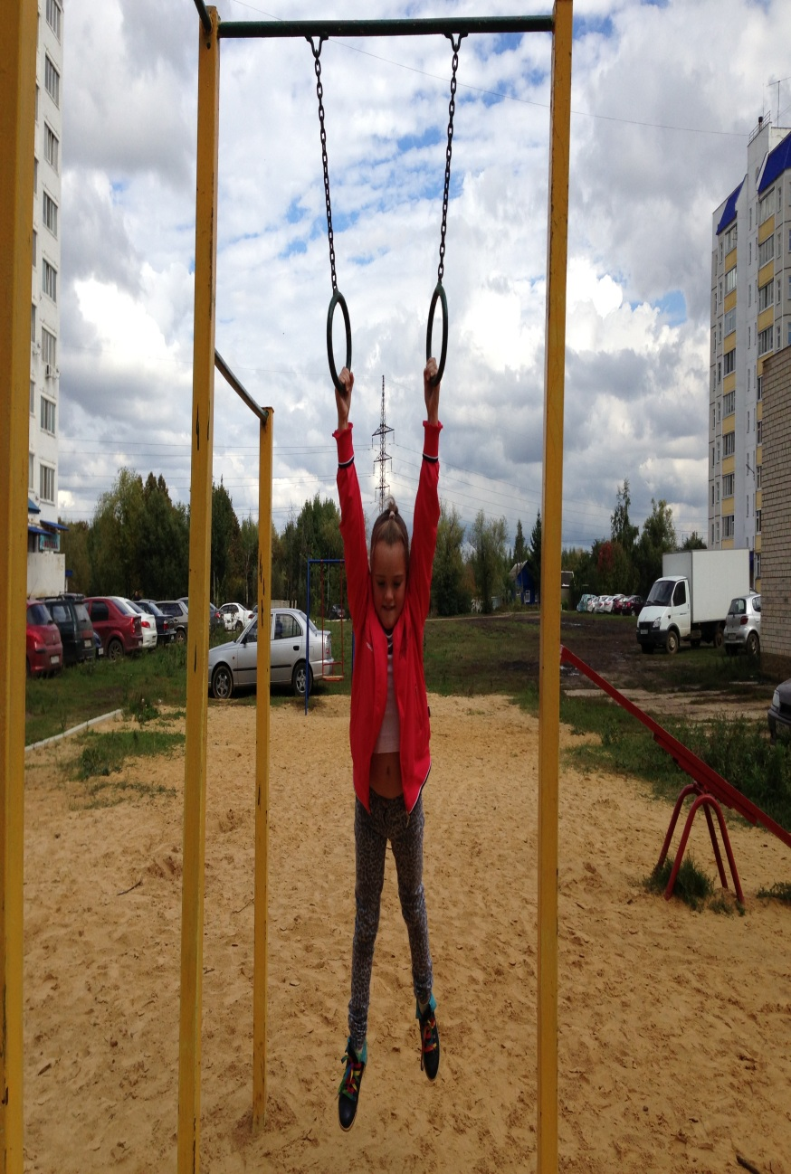

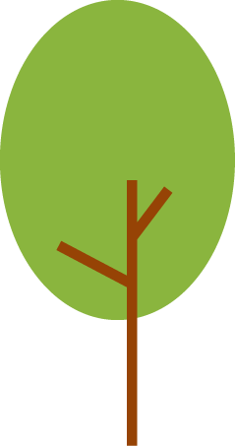

A WIDE VARIETY OF EXCITING ACTIVITIES

Skateboarding is great! It develops all groups of muscles. There are competitions in skateboarding in many cities and towns. It’s so exciting!

Climbing trees is a kind of sport for kids too! Do you agree with me? What a good climber I am!

Look! I can do this! I’m sporty, aren’t I?

What about you?

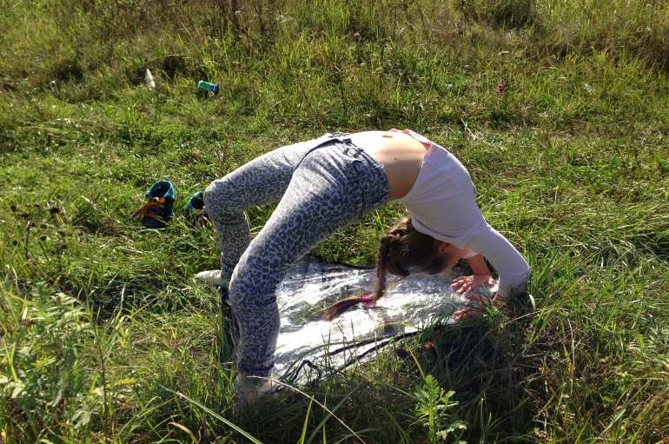

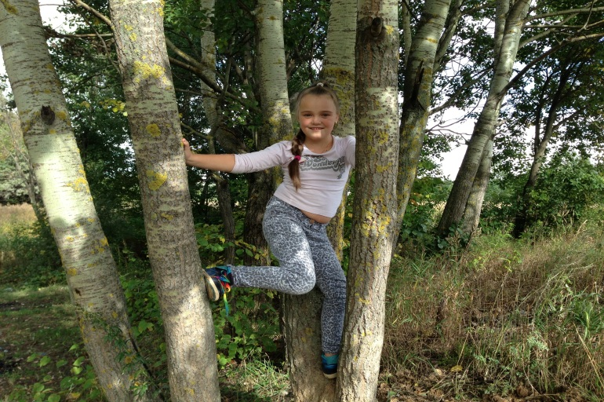

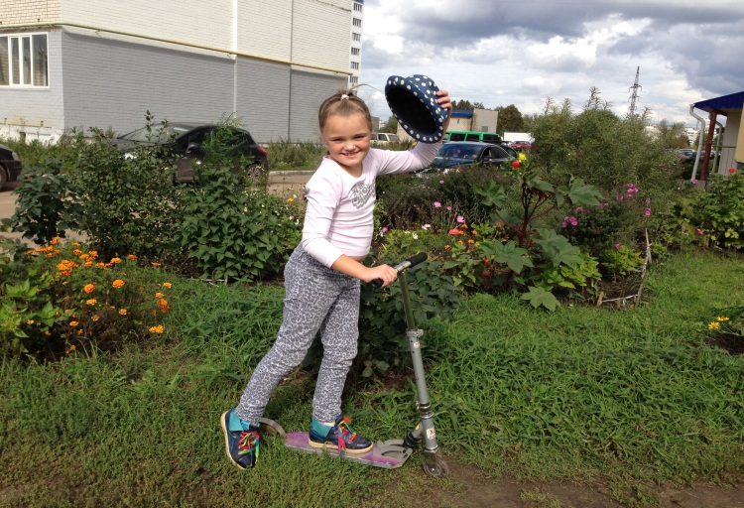



RIDING A BICYCLE

It is exciting to ride a bike! It’s my best hobby! I can do it all day long! When I ride a bicycle in the dark the only thing I need is a small lamp! Then I will never hurt myself and people around!

I advise you to ride a bicycle! But, please, be very careful! Don’t bump into other kids! You will have problems…

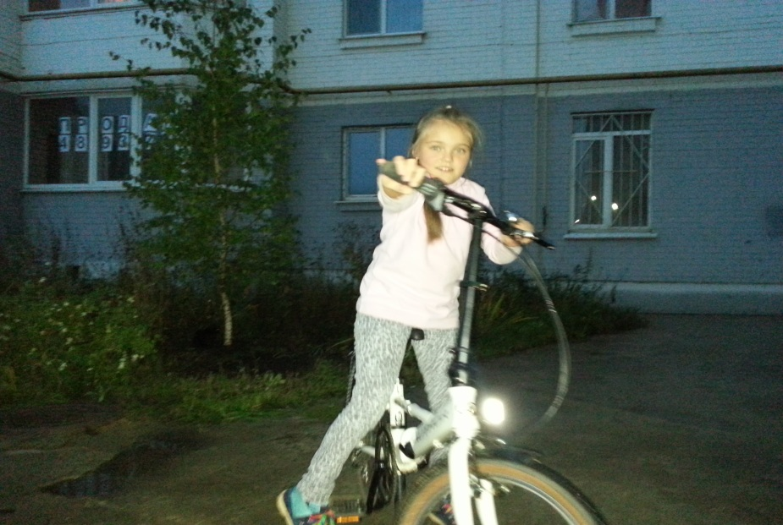

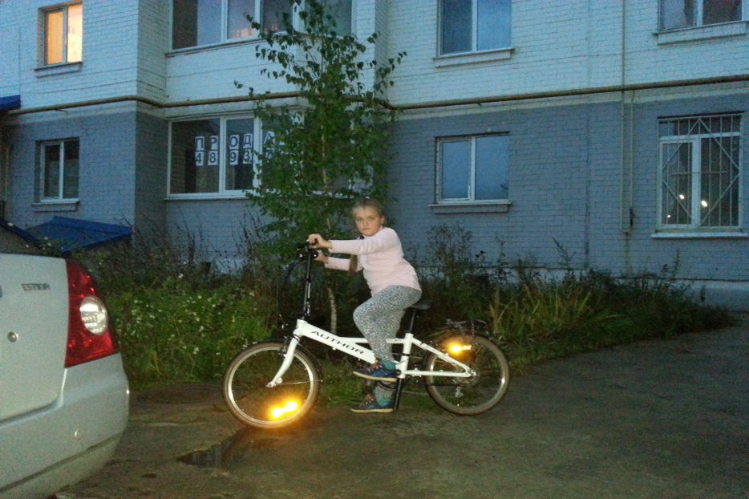

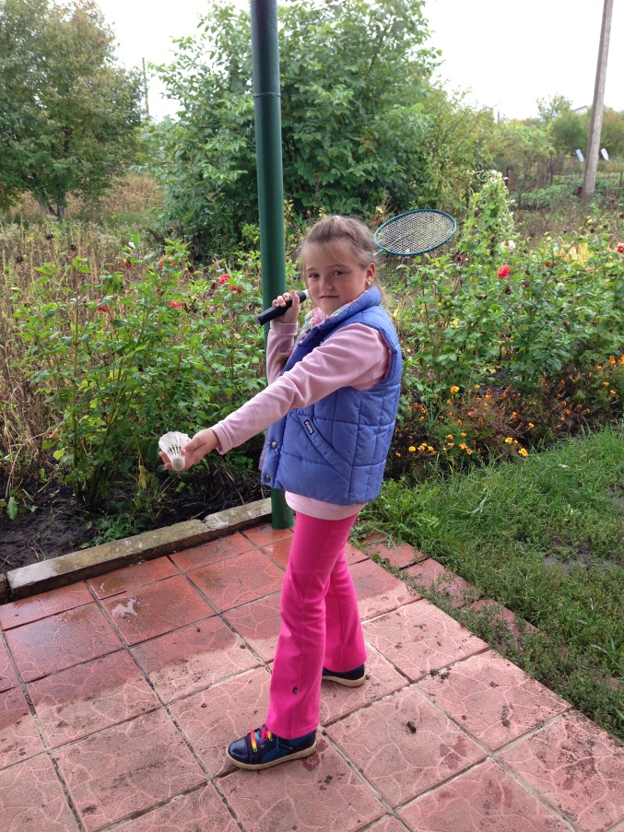

SWIMMING

Swimming is a favourite activity for all boys and girls. It’s cool if the river is clean! But sometimes we can’t do it because some rivers are polluted. It is a pity!

Please, never swim in dirty water! It is dangerous!

PLAYING BADMINTON

I enjoy playing badminton! It develops reaction!

Can you play badminton well? I can show you the way! Then you will forget about all your troubles! It’s a lot of fun!



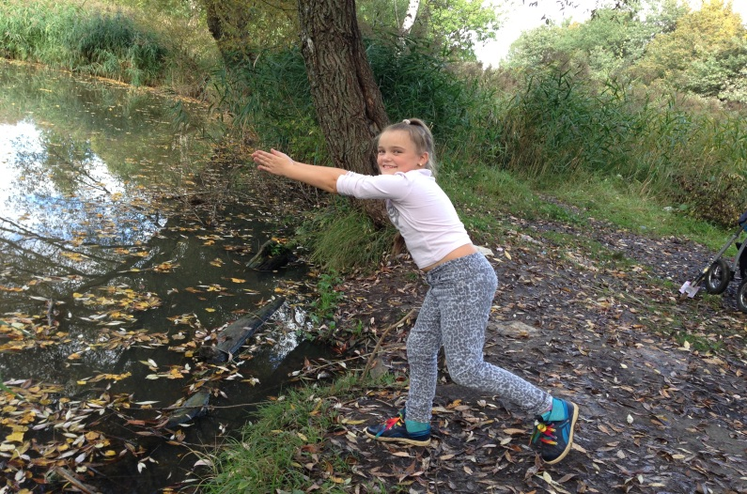

DOING MORNING EXERCISES

Do stretching morning exercises! It’s the best way to “waken” up your muscles and get them ready for the day. You will feel as fit as a fiddle and be in a good mood!

Our summer holidays came to an end…

HURRAH!!! I’m at school again!!! I am very energetic and “an energy crisis” is not for me! I hope sport will help me to have brilliant results in my study!

* Все фотографии взяты из личного архива автора с разрешения родителей.
* Изображение взято с сайта <http://anglyaz.ru/>

Ddct

