

**Summer – The Best Time For Sport**

**Майс Анастасия Владимировна**

***р.п. Тальменка Алтайский край***

***МКОУ «Тальменская СОШ №3»***

***Ученица 5 класса***

**Учитель: Таратынова Марина Николаевна**

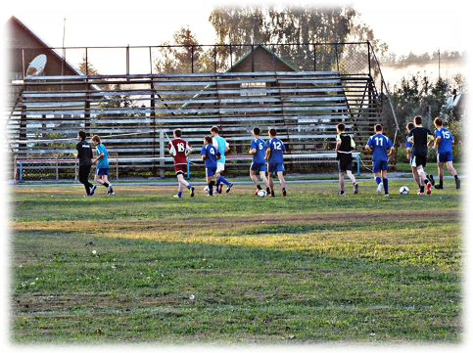

***Summer is the best time for sport, because only in summer we can swim, run, skateboard, cycle and play games in the street. Last summer I often went to the stadium to watch football matches. My mother and I like to see how my elder brother Jan plays football in our local team.***

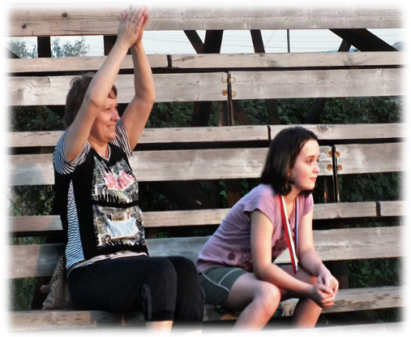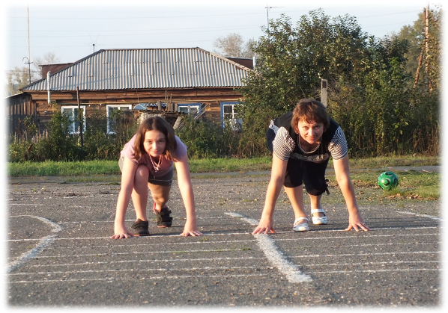

In ***Summer I like to run. Sometimes we compete in running with my mum. My mum is a very good sportsman too and she wins in our competitions. But I hope to run the first someday.***

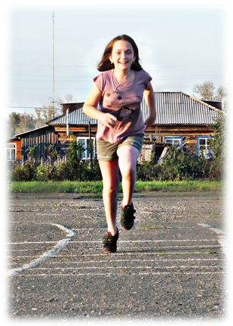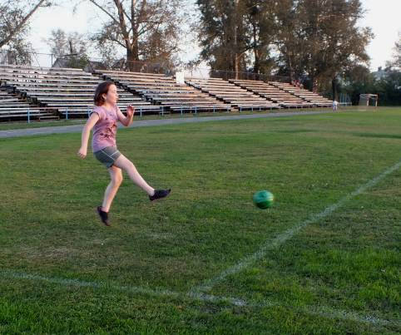

***I am fond of playing with a ball. I played football with my brother. He told me the rules and we often went to the stadium to play football.***

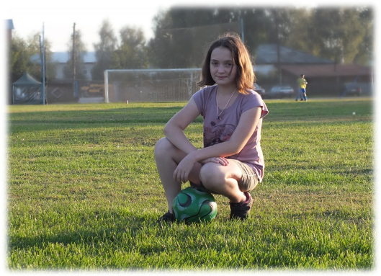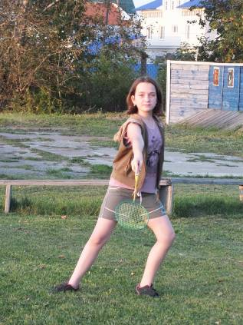

***My favourite game is badminton. My girl-friends and I played it every day. I think playing badminton is very useful. It makes people strong, healthy and happy.***

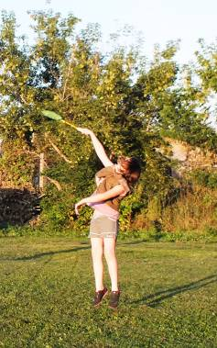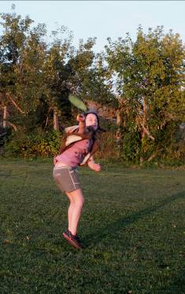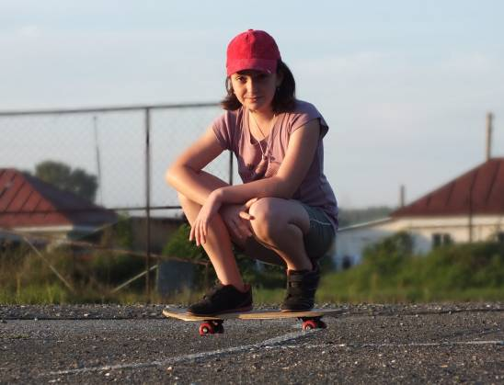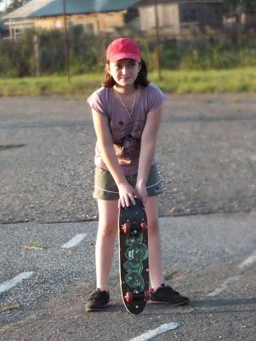

***Skateboarding is very popular among my classmates and I like it too. It’s very exciting and interesting.***

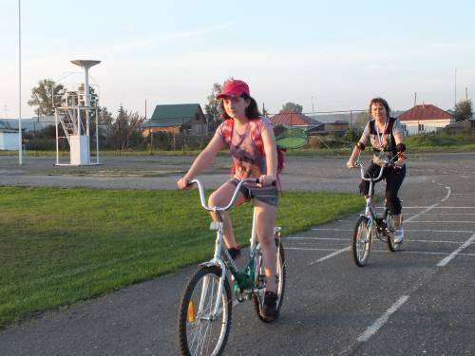

***Cycling is my hobby. In summer I took part in cycling competitions and won the second place. You can see my medal in the photo.***

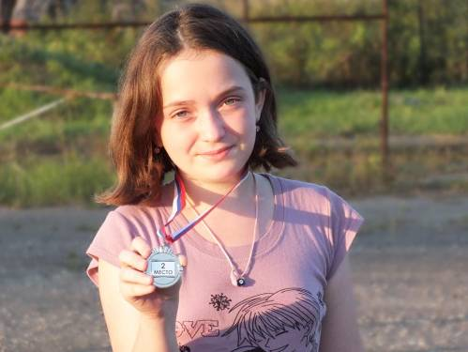

***I n summer I ran, jumped, played different games and now I am ready for my school. I am healthy and happy and I will have PT lessons at school.***

**Все фотографии взяты из личного архива. Вышеуказанные фотографии используются с разрешения родителей.**