Конкурсная работа

фотоотчёт "Summer – the best time for sport"

Иноземцев Никита,

3 класс,
МБОУ - лицей № 4 имени Героя Советского Союза Г. Б. Злотина города Орла.
Учитель: Горинова Светлана Александровна

Hello,
My name is Nikita. I am 10 years old. I live in Orel. I love computer games and reading. But most of all I’m crazy about sports and adventure!!!

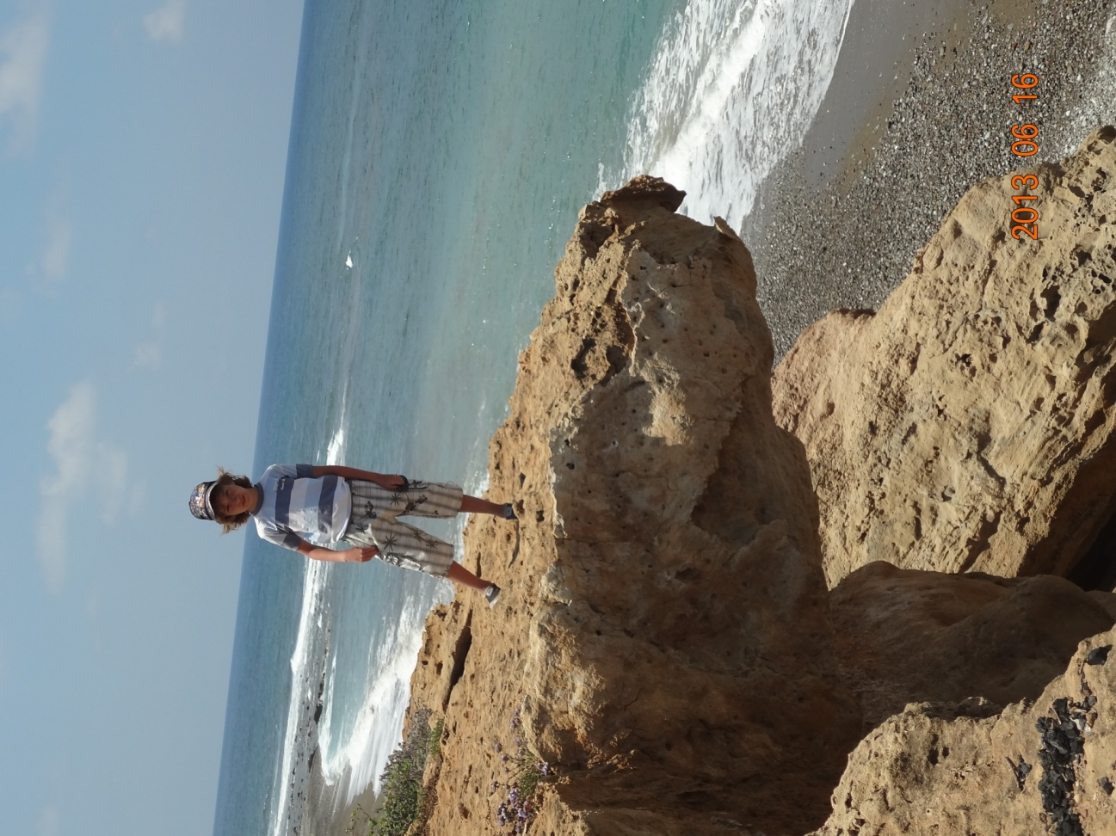

I like to climb mountains and rocks. It’s fantastic!

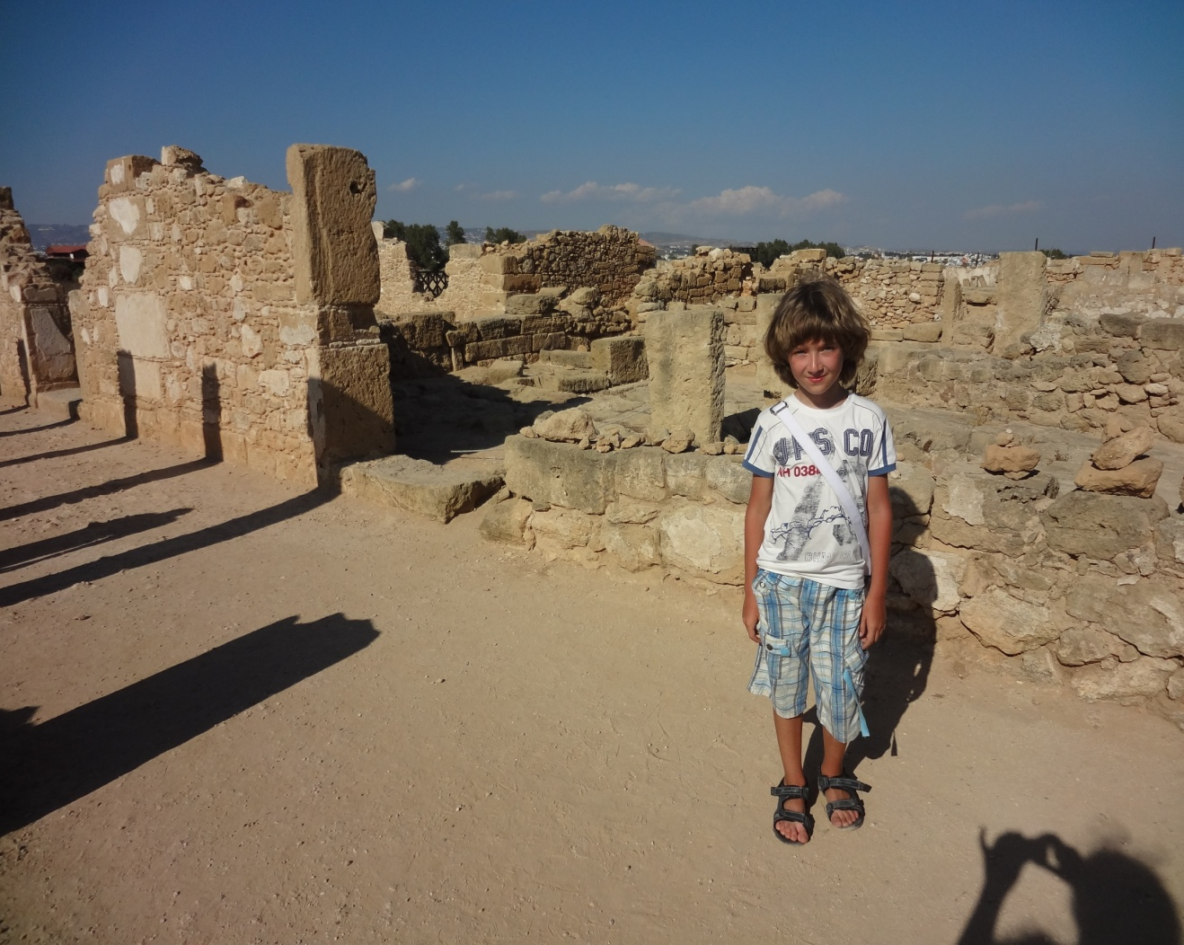

In summer my parents and I go on a journey to the sea. We are very active and always look for interesting and unusual places.
When we visit them we try to combine going sightseeing and doing sport. We play volleyball, football, badminton and tennis and have a lot of fun. We also take photos of various interesting moments in our life.

Will you have a look at them:

We are in a boat! It’s great!
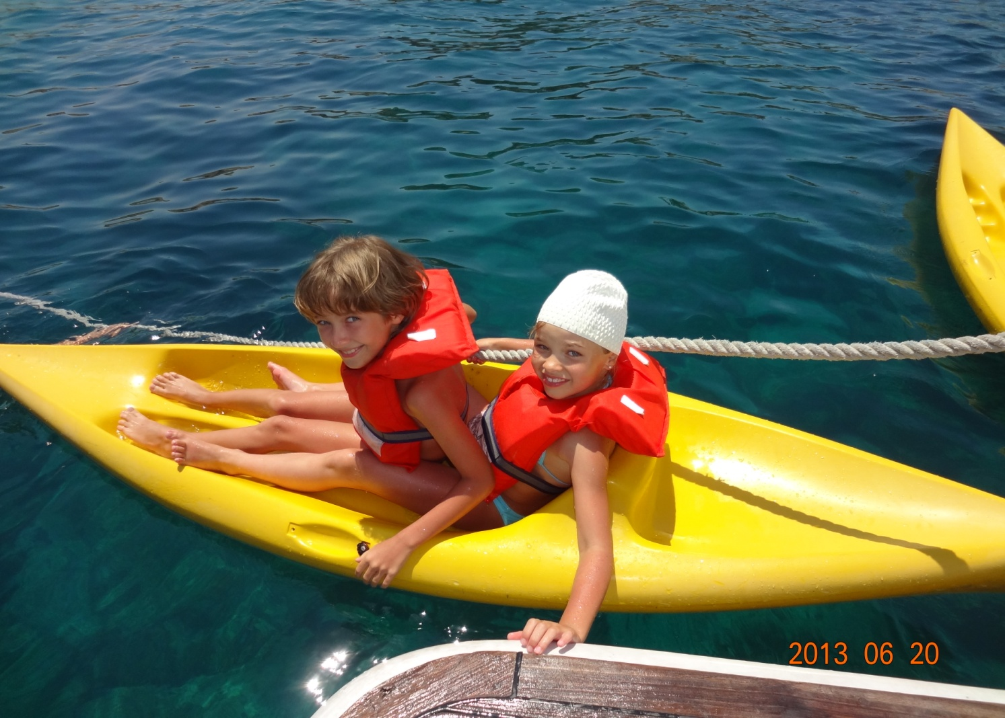
It’s a bit dangerous but we like it!

I learnt to swim this summer! I was happy!
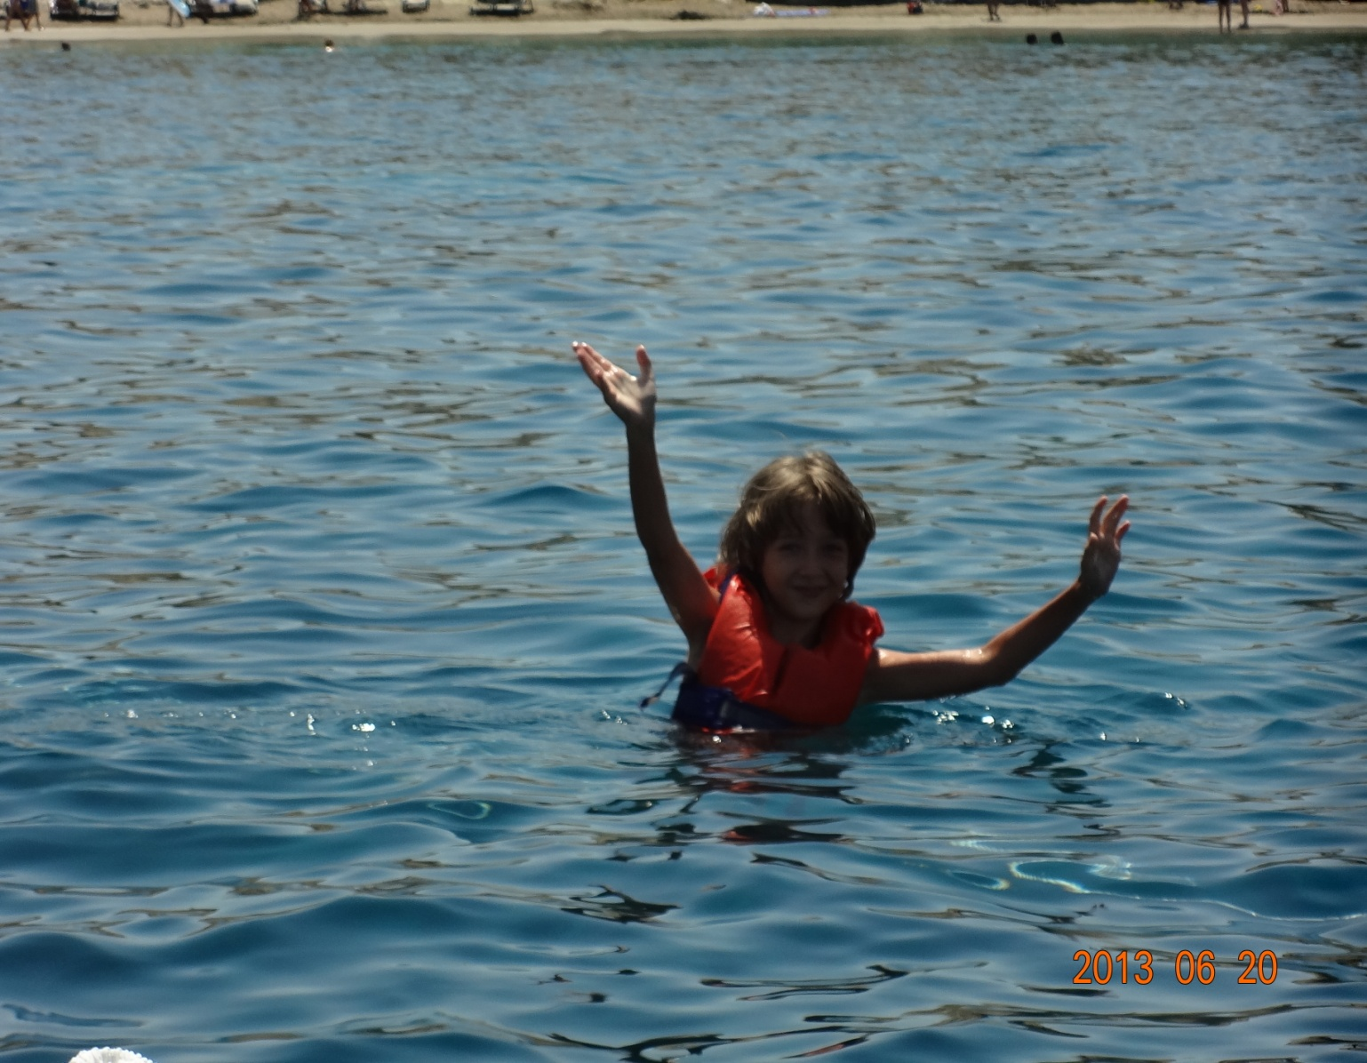
My Mum and Dad say that I am a good swimmer! I’m very proud!

When we got back to Orel I immediately went to our central stadium to join a swimming club. But the pool was closed for the summer. I was so unhappy… and my parents decided to give me a swimming pool, so I can train near my house!
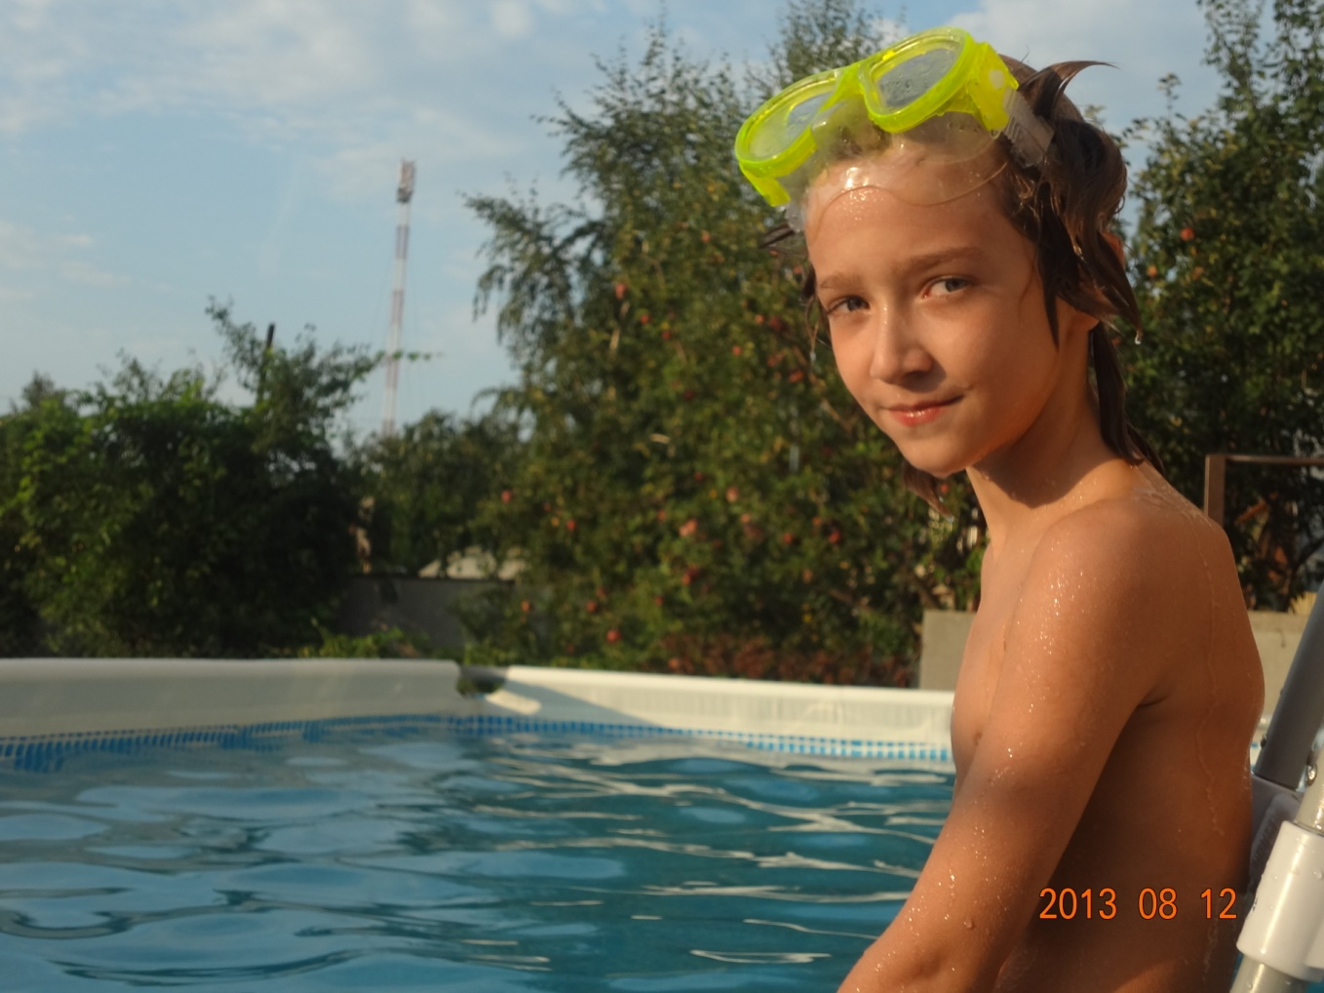

INow I can swim in the pool when I want. I am looking forward to joining a group of the swimmers in the real pool. I hope it will open soon after the reconstruction.

Summer is the best season of the year. Now I understand that it is very important to go in for sport. Sports activities help me to be strong and fast! More than that, sport helps to learn something new and make new friends.
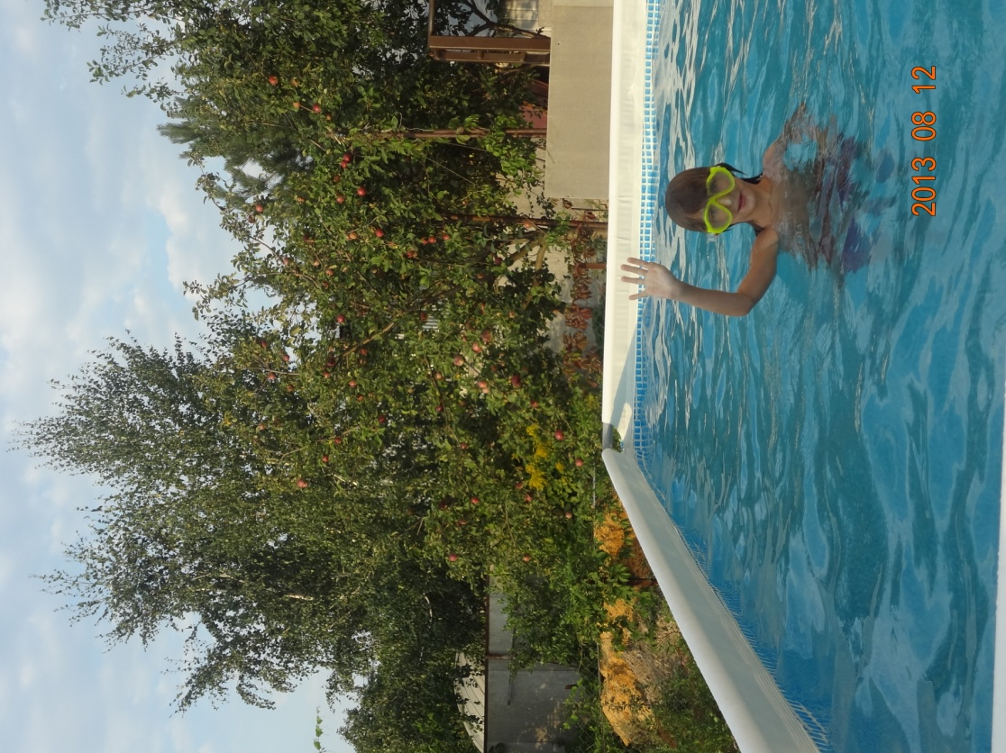
I want to learn to play tennis and I hope it will be my new hobby that I will start next summer. But that will be another story))).
Summer is the best time for sport!

Dear friends,
Be active! Go in for sport and you will never have any problems with your health!
- Фотографии взяты из личного архива с разрешения родителей
- Картинка взята с http://images.yandex.ru/

