КОНКУРСНАЯ РАБОТА
фотоотчет "Summer – The Best Time For Sport"

Горинов Виктор Владимирович, город Орел,
ФГБОУ ВПО "Российская академия народного
хозяйства и государственной службы при
Президенте РФ", студент 1 курса факультета
«СОЦИАЛЬНЫЕ ТЕХНОЛОГИИ»,
преподаватель – Сатарова Лилия Викторовна

Sport is one of my favourite activities. Most of all I enjoy doing sports during my summer holidays when I am not as busy as a bee getting ready for my classes.
This summer was special for me. It was extremely full of various sporting activities and events. I managed to do so much and it helped me to make an important conclusion: if you planned your day in a perfect way combining exams and sports you would succeed!

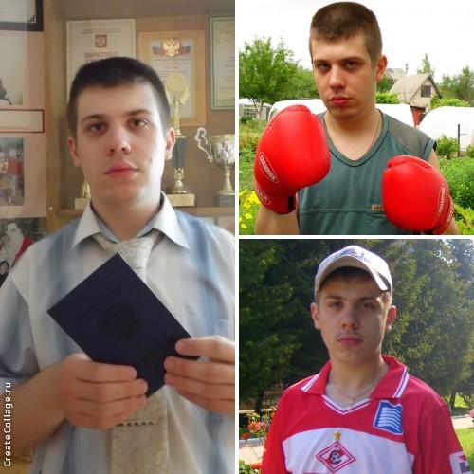

I had a tremendous success in some activities. In my opinion, it was because of my active life position and participation in sports events.

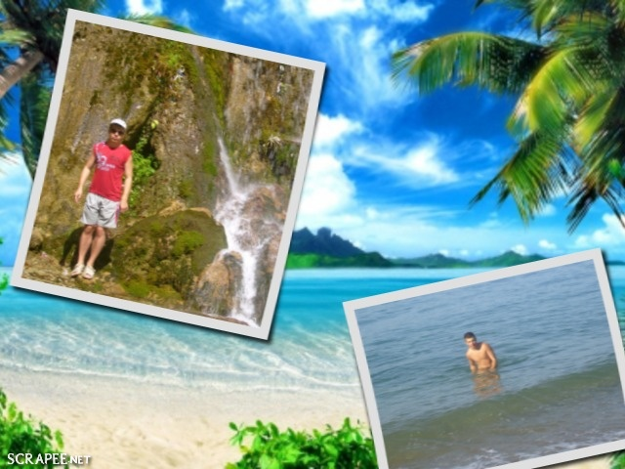
Summer is the best time for going to the seaside. I spent a week at the Black Sea. It was a unique opportunity for me to climb mountains and to swim. Unfortunately, I can’t say that I am a perfect swimmer. But I can climb mountains and hills rather well. I am not afraid of height. The height of the mountains never discourages me.
When I was a little boy my mum used to say “Don’t be afraid of any difficulties! Be brave and confident! Faint heart never won fair lady!” I’ve learnt these words as well as irregular verbs which I had to learn by heart when I misbehaved. Now I’m sure that all proverbs and sayings are wise and if you follow their wisdom you will have a great success!
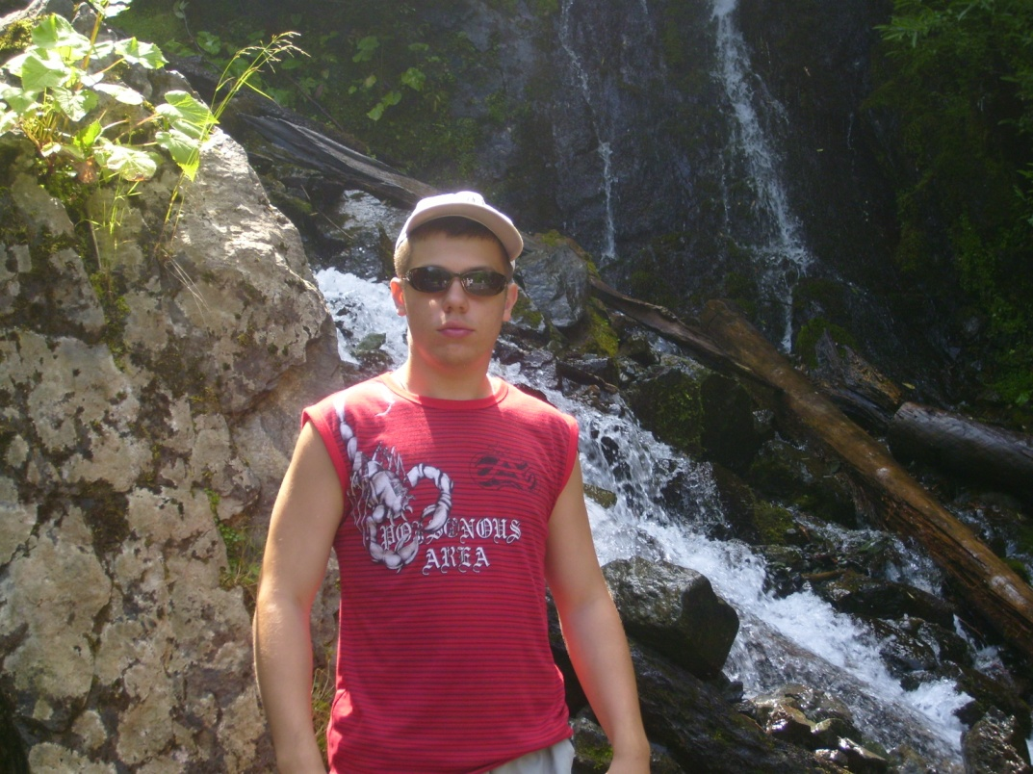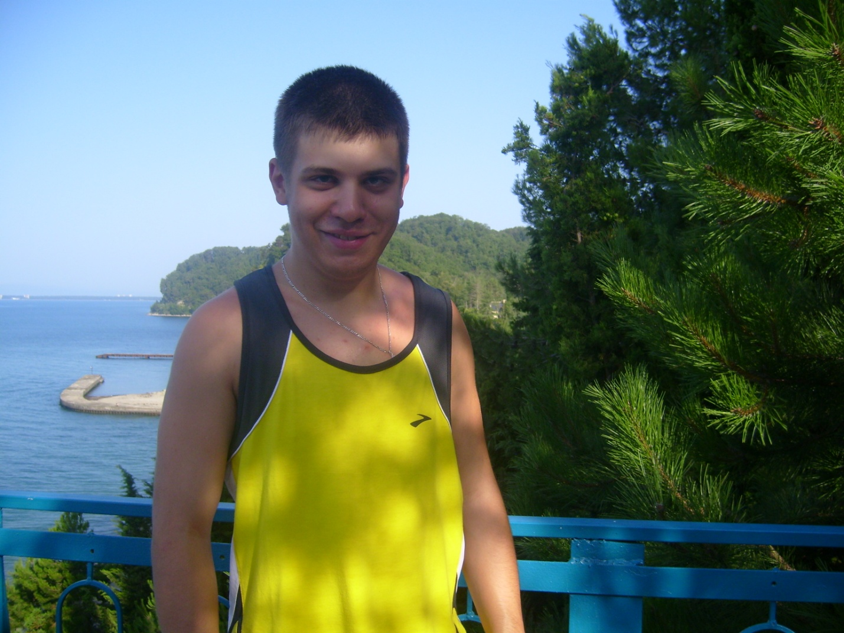

Summer is the best time to start a new hobby. Climbing mountains turned out a new hobby for me. I climbed a lot this summer! Of course, it was extremely dangerous on the one hand, but it was rather exciting on the other. At first I was as helpless as a babe. But our group instructor was very skilful and wise! He taught us to survive in dangerous situations.

My friends said that when I first reached the top of a small mountain I was as pale as death. It was as clear as mud that I did it and the sense of pride overwhelmed my heart!
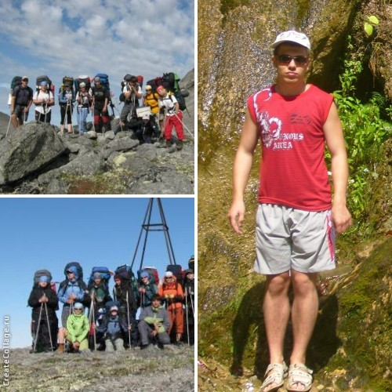

Climbing mountains helped me to be as brave as a lion and as firm as a rock. I’m sure such traits of character will help me in the future.

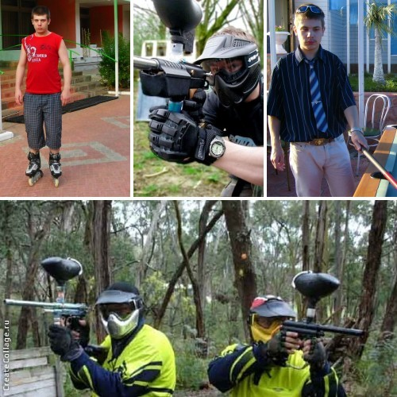
I enjoyed roller skating, playing billiards and paintball. Nothing can beat these activities!

When it rained I spent a lot of time in the gym. I attended individual classes and I did it with great pleasure. Different machines, a certified personal fitness trainer and good environment for exercising were at my disposal. That was terrific! No crowds of people! Quiet music! Friendly atmosphere!

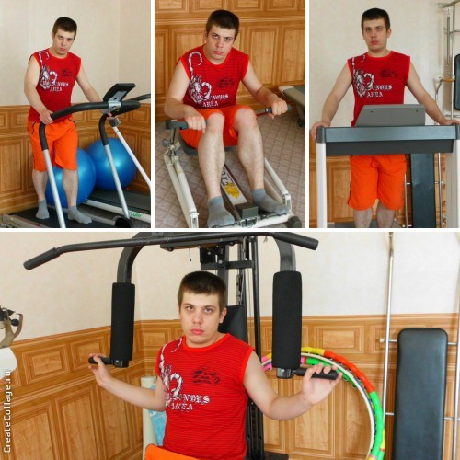

I was lucky to have an experienced trainer who taught me how to do exercises in the proper way. When I heard the news about my personal trainer I was dying of curiosity to have a look at him! We made friends rather quickly and I understood that he would never show off like a Texas ranger but would try his best to make me look like a real athlete. I was as happy as a king! It was essential for me to acquire the proper skills of how to do various exercises using safe exercise technique. It wasn’t as easy as ABS at all! My trainer was as strong and handsome as a young Greek god! He became an idol for me and I started training hard. Gym exercises helped me strengthen and target every major muscle group in my body.

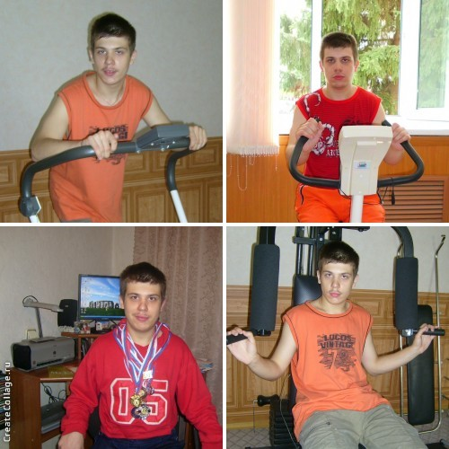

At home I used multigyms, the best fitness and bodybuilding machines. Multigyms are a great piece of equipment to have at home because one machine allows you to train a wide range of muscles! I could do a chest press, shoulder press, pull downs, leg presses and much more, all on one piece of equipment. They provided up to 35 exercises. It was fantastic to use them!

I can’t imagine my summer holidays without skating because it’s my hobby and I skate during all the seasons of the year! Look! It’s a picture of my friends, my mum and me!

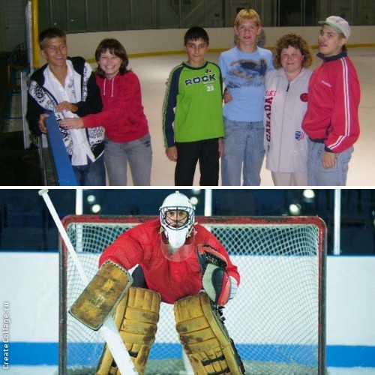
I had an overwhelming desire to learn to play hockey these summer holidays. I tried myself as a goalkeeper. I was so enthusiastic! I fought like a lion but all my efforts ended in failure! So I understood that hockey wasn’t for me!
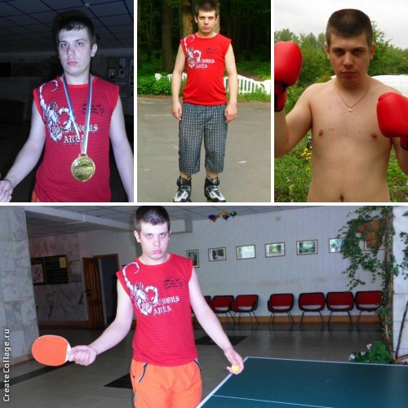

In the evenings I was engaged in boxing and playing tennis. I was the second in a tennis competition. I felt proud of myself. My parents were in seventh heaven! It was great!

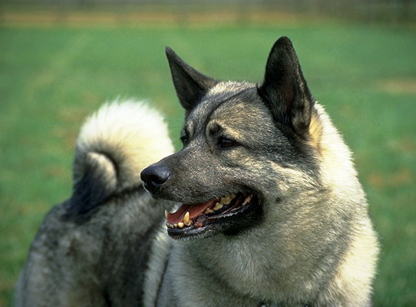
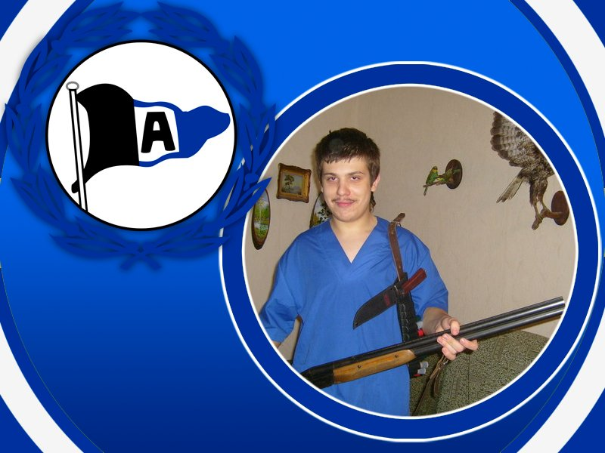

Sometimes my dad and I went photohunting. Photohunting is a kind of sport for me because I always choose long-distance routes. I admire the scenery and the world of birds and animals and I take funny pictures. Long walks in the country are like a marathon for me and they help me to be as fit as a fiddle. My dad and I are like real rangers! We know the countryside like the palms of our hands. This summer we had a very important mission! We were to find animals and birds that were in danger and to help them. We cured a lot of animals. We did a good job! It was terrific!

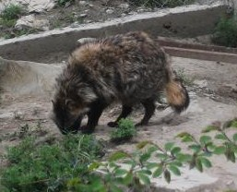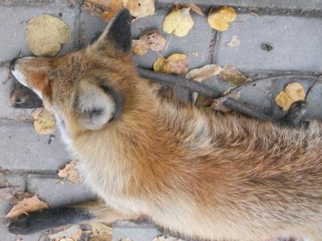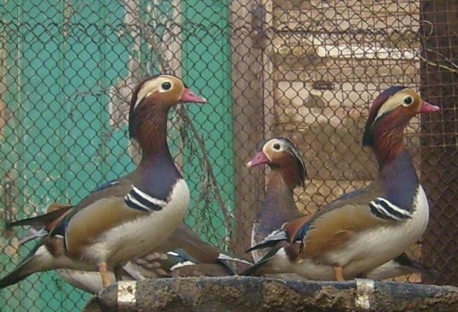

These animals and birds were saved by us!

Frankly speaking, I enjoyed being in the country. My heart was conquered by the quietness of the early morning and peaceful darkness of the evening. My best and true friend Buran accompanied me on my trips.

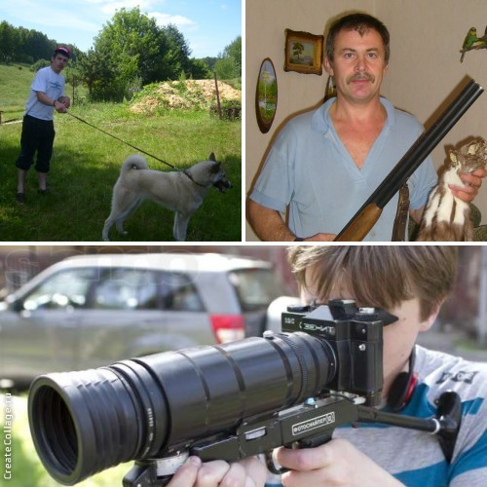

When I was roaming the countryside I could appreciate the beauty of the dawn, the marvellous greatness of hills, the eternal beauty and preciousness of nature.
In August my friends and I went on a hiking trip. We lived in tents, sang songs, played sports games and had a jolly good time! It was fantastic!
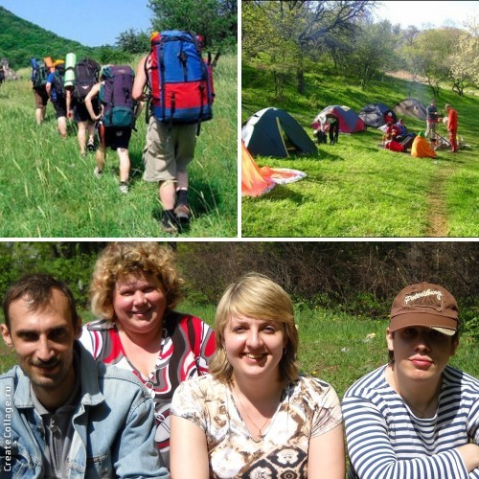
These summer holidays were the best time for various activities! I could kill two birds with one stone: I admired the wildlife on the one hand and improved my health on the other! That’s why I can make a conclusion: if you spend your summer in a clever way you will always be an eager beaver, full of energy and high spirits!

In my report I used

http://www.answers.com/library/Dictionary-cid-2227498
http://createcollage.ru/
http://ru.picjoke.net/
http://images.yandex.ru/yandsearch?source=wiz&uinfo=sw-1263-sh-881-fw-1038-fh-598-pd-1&p=1&text=%D1%81%D0%BE%D0%BB%D0%BD%D1%8B%D1%88%D0%BA%D0%BE&noreask=1&pos=39&rpt=simage&lr=10&img_url=http%3A%2F%2Fthumbnail077.mylivepage.com%2Fchunk77%2F1152287%2F803%2F

