"Summer –
the best time for Sport"

Куркин Евгений
8 класс
МБОУ «Гимназия №1»
г. Рузаевка, Республика Мордовия
учитель: Паркина Людмила Константиновна

Summer for Sports

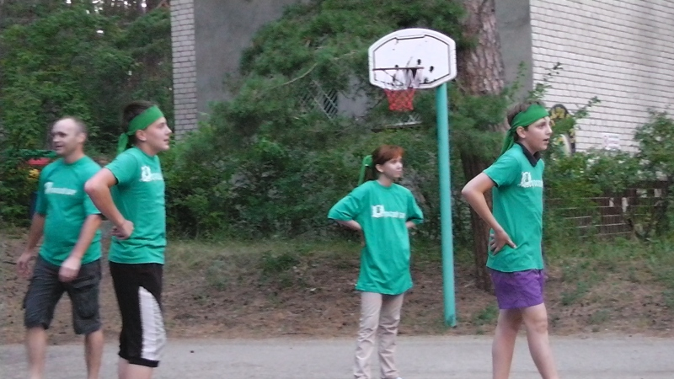

In summer I like to play football and volleyball
with my friends.

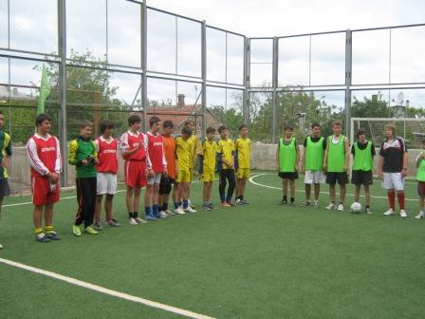

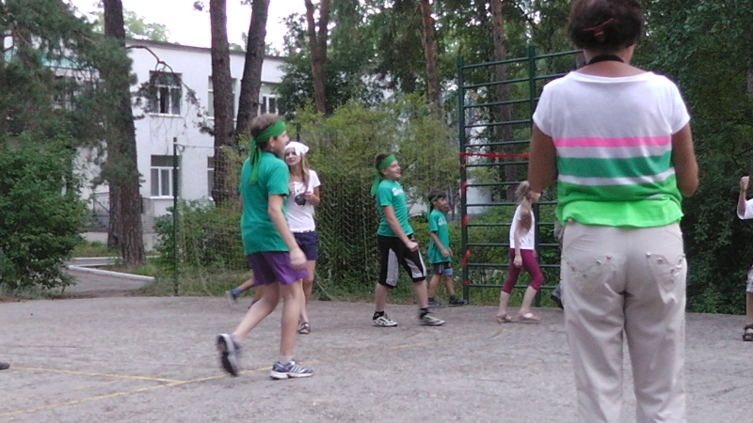

When I go in for sport I feel wonderful.
I am cheerful, energetic, active and full of energy.

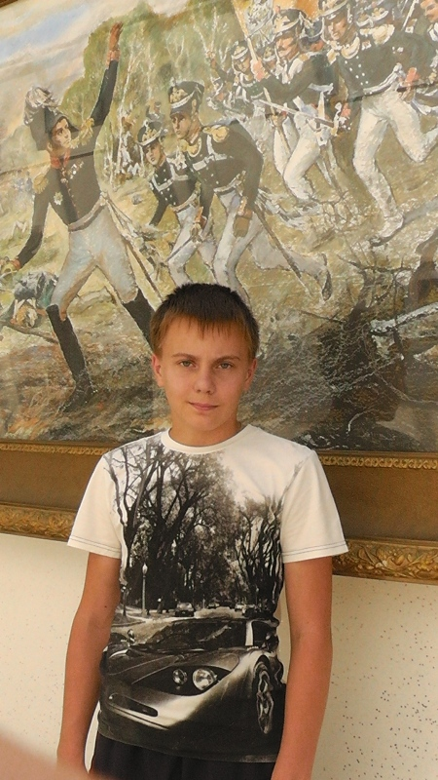

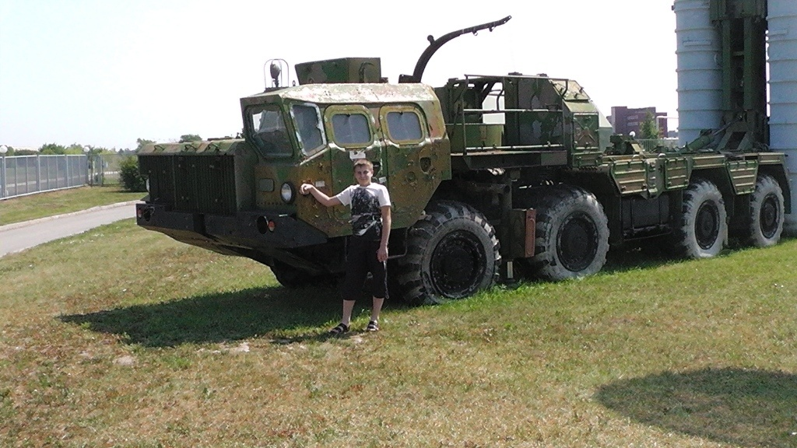

I can swim very well. I go to the swimming pool
twice a week. Swimming helps me to stay in
good shape, to keep fit and to be healthy

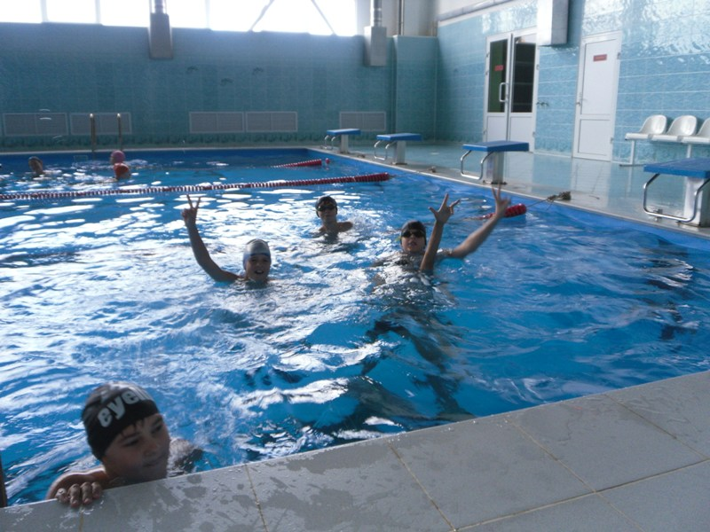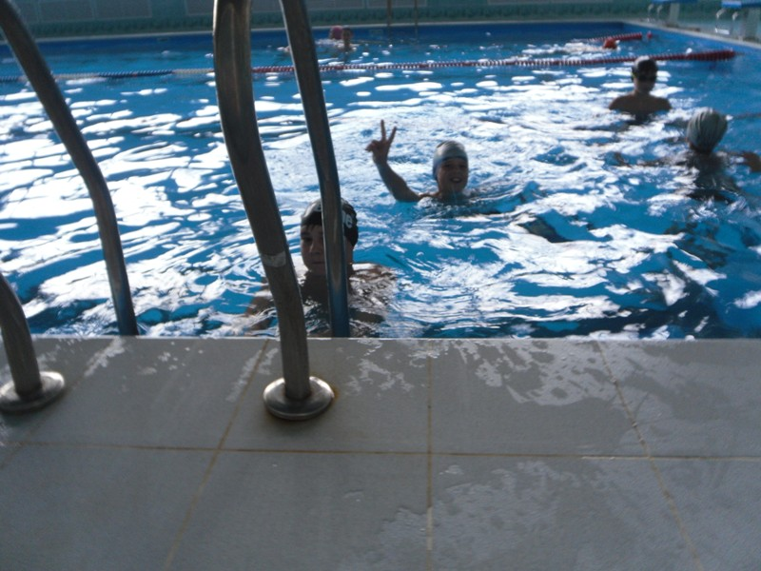

I prefer to rest by the lake or the river and swim there

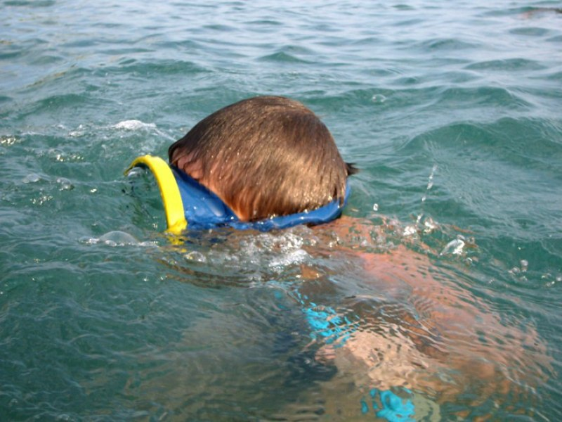

I enjoy many sports, but best of all I love
Kyokushinkai karate.

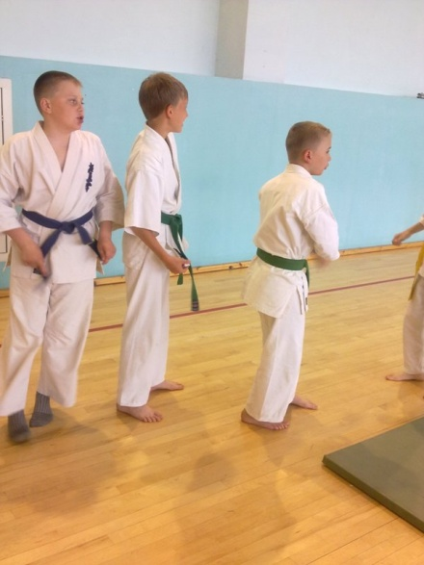

We have a karate school in our town and
I go there four times a week

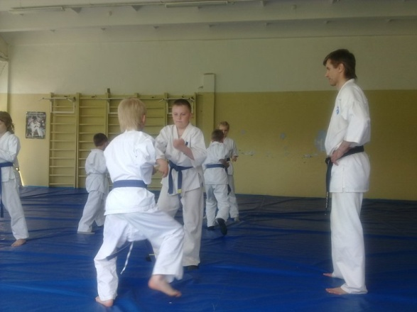

« A sound mind is in a sound body»

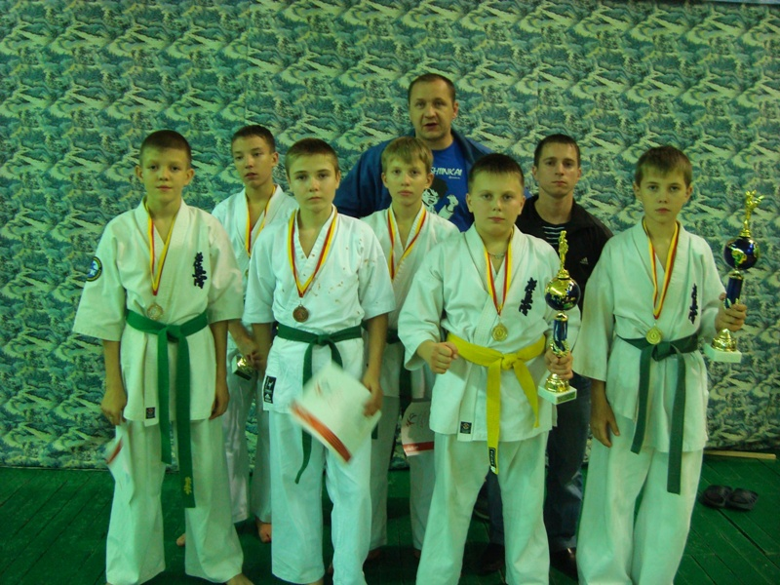

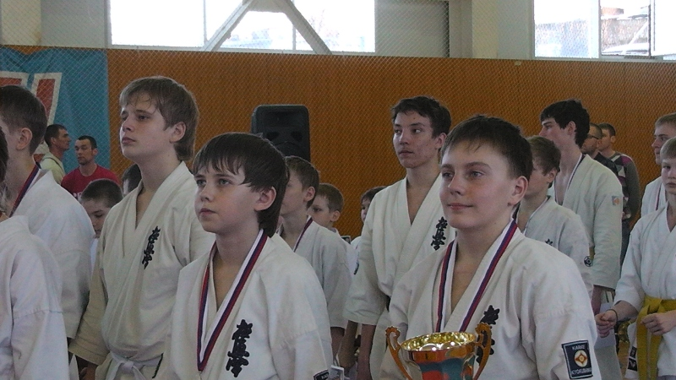

Hurrah! I am a champion!

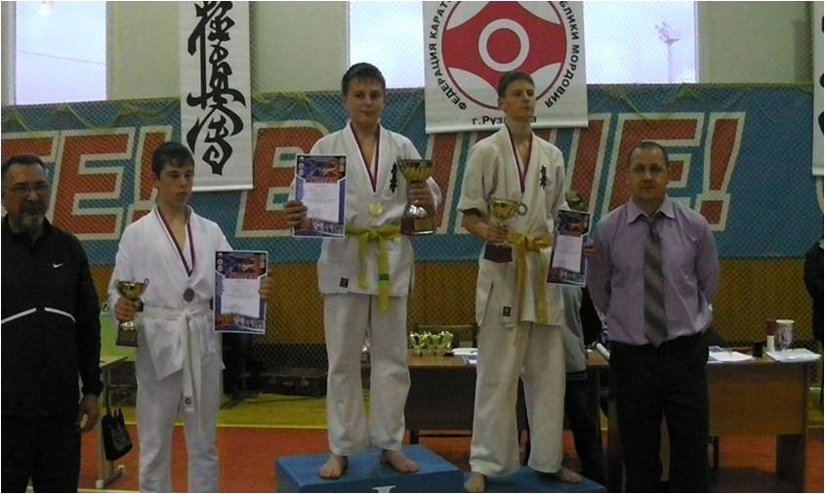

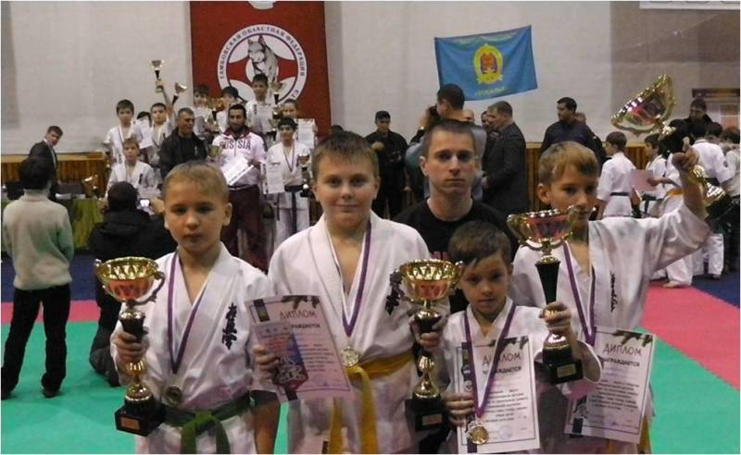

My dream is to become a master of sport

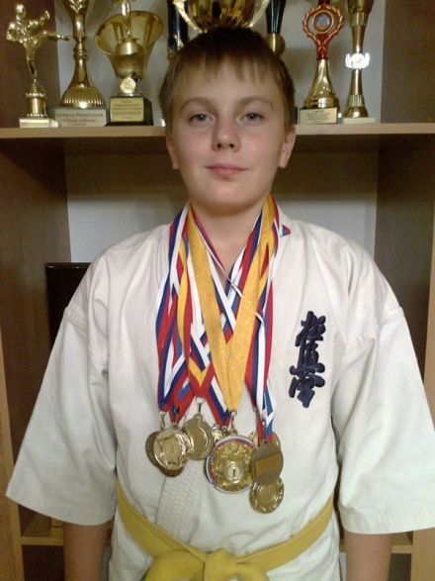

Sport plays a very important role in my life.

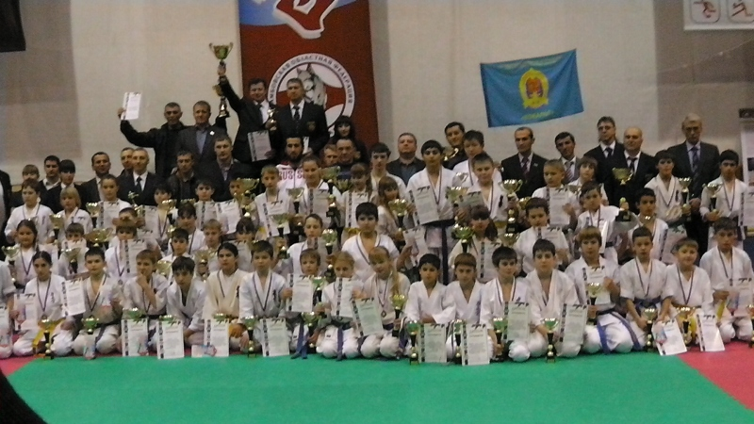

Все фотографии взяты из личного архива. Вышеуказанные фотографии используются с разрешения родителей.

