***Конкурсная работа***

**"Summer – the Best Time for Sport"**

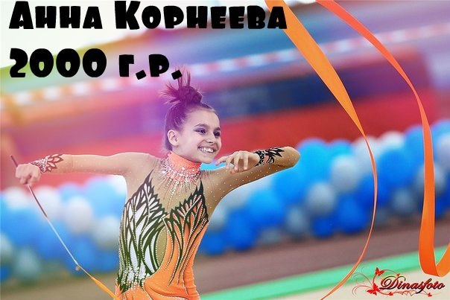

**Корнеева Анна Александровна**

**р. п. Городище**

**МБОУ «Городищенская СОШ №3»**

**7 класс**

**Учитель: Туркия Татьяна Григорьевна**

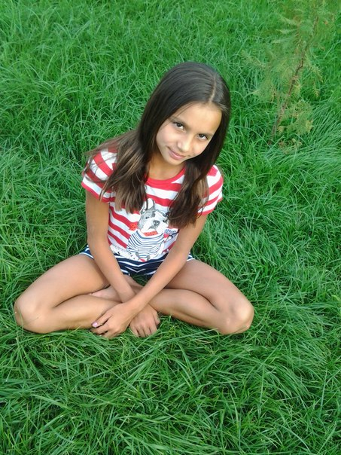

**Hi! Here I am!**

**I’m Anna Korneeva, the 7 th grade pupil.**

**Are you interested in my summer photo report?**

**Then… Let’s start!**

**I’m keen on Gymnastics Rhythmic.**

**By the way, do you know that there are 3 kinds of Gymnastics? They are: Gymnastics Artistic, Gymnastics Rhythmic and Trampoline.**

**I’ve been doing sports since 6 years old. And my model is one of the best Russian and World’s Gymnasts - Alina Kabayeva. I dream of succeeding in Gymnastics Rhythmic like my favourite sportsman.**

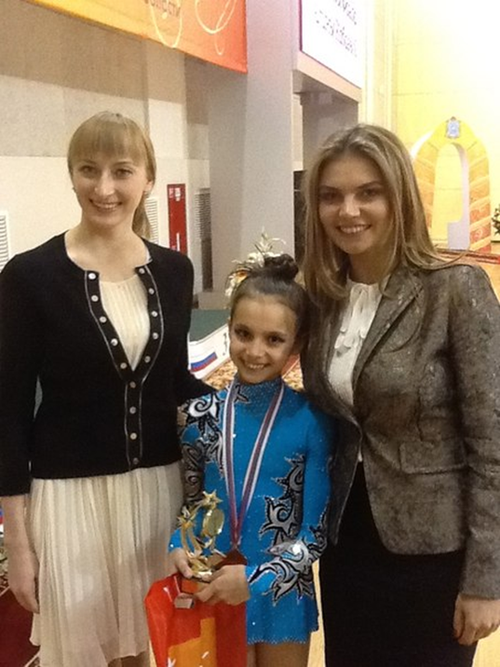

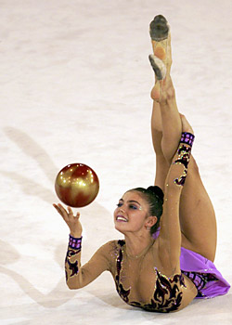

**So I can’t imagine my life without sport even in summer.**

**And it began with travelling to Turkey. There our united team prepared for competitions.**

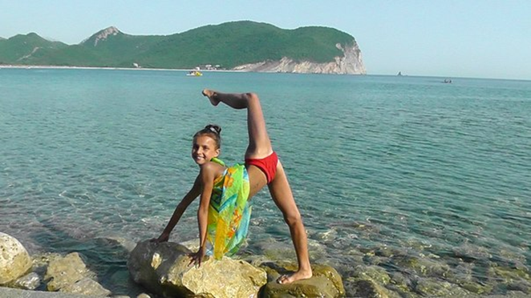

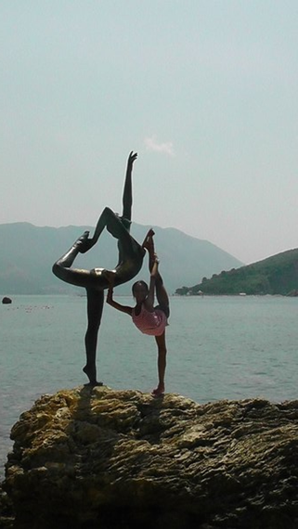

**Isn’t it fantastic to do stretching exercises at the seaside?!**

**Afterwards we took part in Russia’s Summer Sports Festival in Krasnodar. We did all our best and became first! Hurray!**

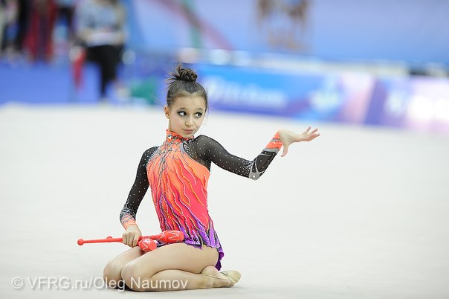

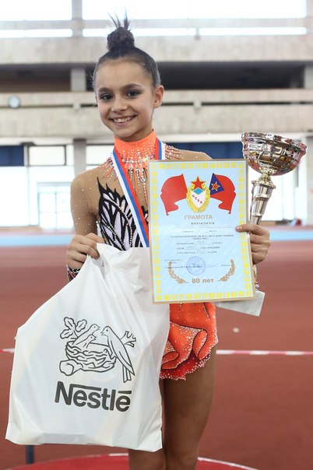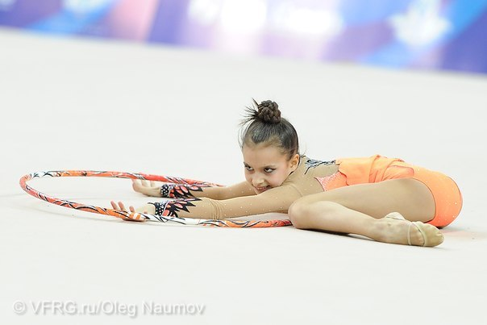

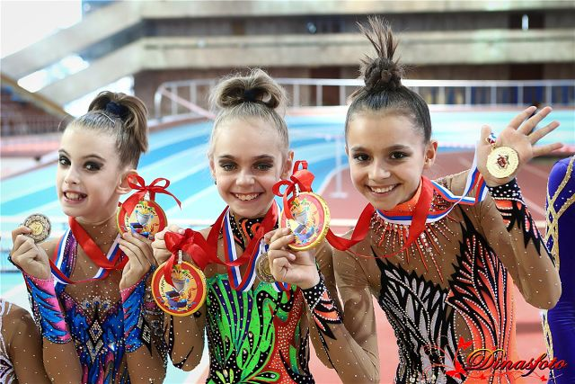

**But most of all I like to be with my close relatives and friends. This summer we went fishing, swimming and walking my cute dogs together.**

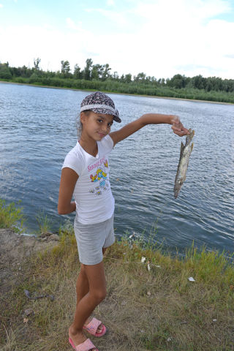

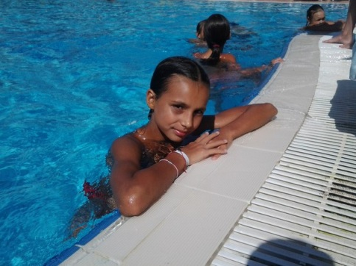

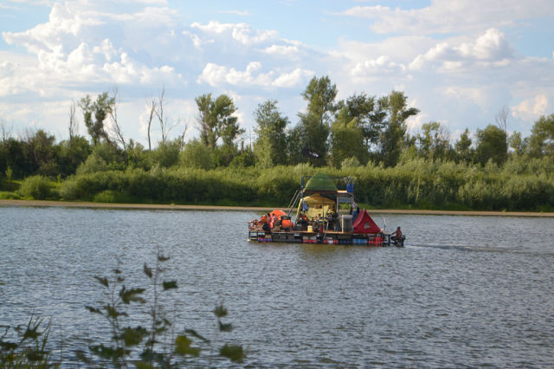

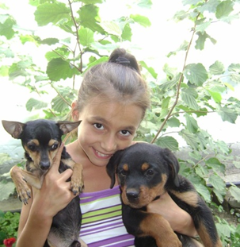

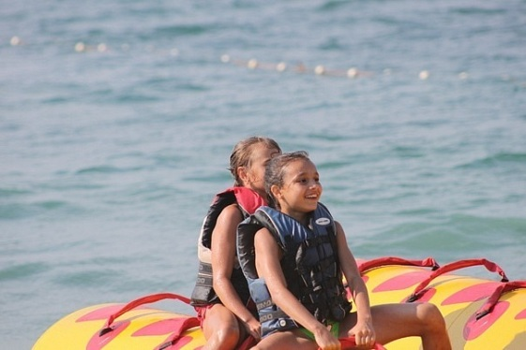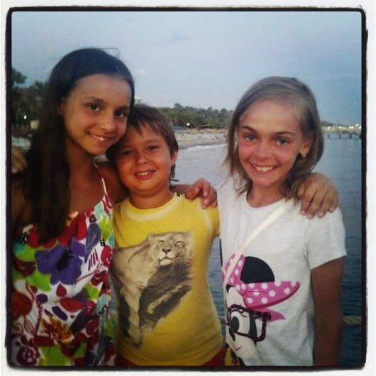

**You can't put a limit on anything. The more you dream, the farther you get.**

**Michael Phelps**

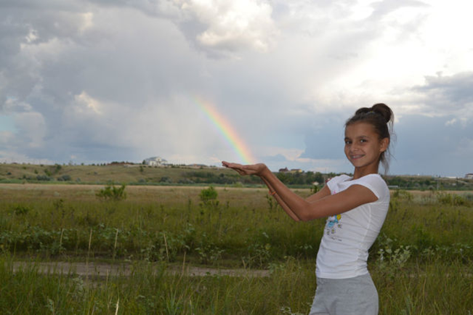

**Goodbye, my dear friends! Thank you for your attention.**

**I wish you to be healthy and happy. Go in for sports, keep fit and eat nutrition!**

**Sincerely yours,**

**Anna Korneeva**

<http://www.olympic.org/fig-rhythmic-gymnasticsns>

[www.dailytelegraph.com.au](http://www.google.ru/url?sa=i&rct=j&q=&esrc=s&source=images&cd=&cad=rja&docid=yH6g3pYGjs1xaM&tbnid=hHWt9gxEG90_GM:&ved=0CAQQjB0&url=http%3A%2F%2Fwww.dailytelegraph.com.au%2Fgallery-e6freuy9-1111120102880%3Fpage%3D6&ei=KxI7UvioD4GD4AT8toCoBw&bvm=bv.52288139,d.bGE&psig=AFQjCNGGWqkDqrtZClsiiCdxXPOtDGJMGQ&ust=1379689141491464)

VFRG.ru /Oleg Naumov

<http://www.brainyquote.com/quotes/topics/topic_sports.html>

Фотографии из личного архива Анны Корнеевой