Конкурсная работа

фотоотчёт "Summer – the best time for sport"

Горохова Лолита, 3 класс,
МБОУ - лицей № 4 имени Героя Советского Союза Г. Б. Злотина города Орла.
Учитель: Горинова Светлана Александровна

2013

Hi,
My name is Lolita. I am from an ancient Russian town. It is called Oryol.
I like my town. It is very green in summer and I enjoy playing sports games. I like sport very much.
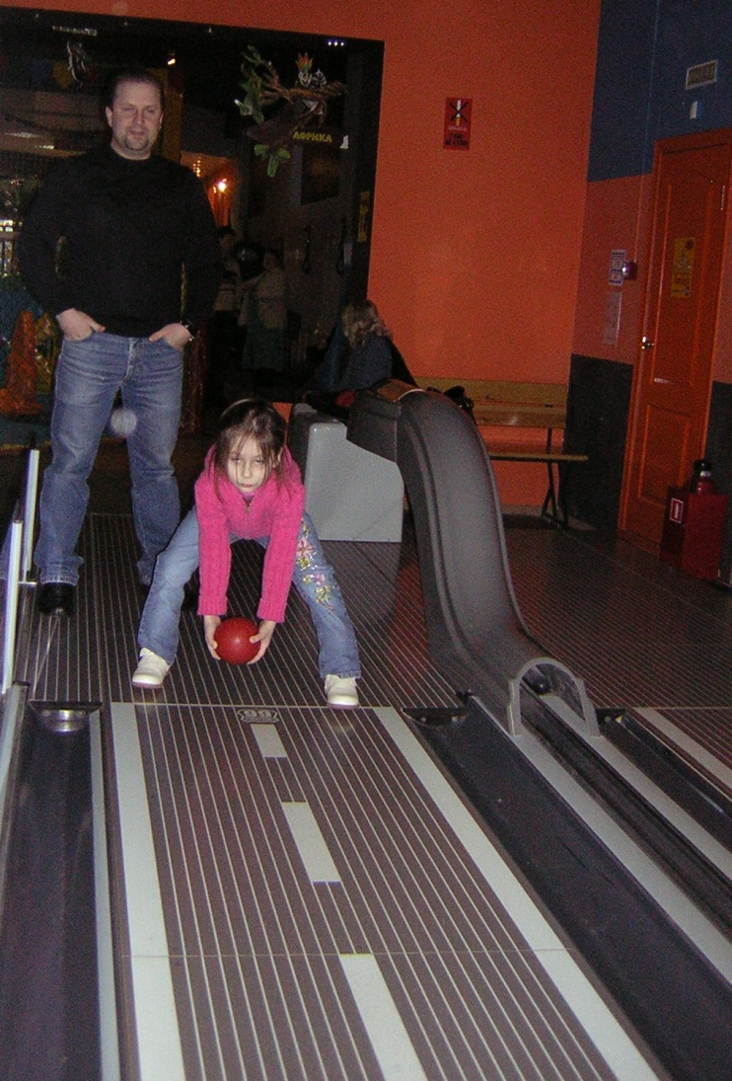
Look! I am playing bowling! It’s great!

I can swim and dive! It’s a lot of fun!
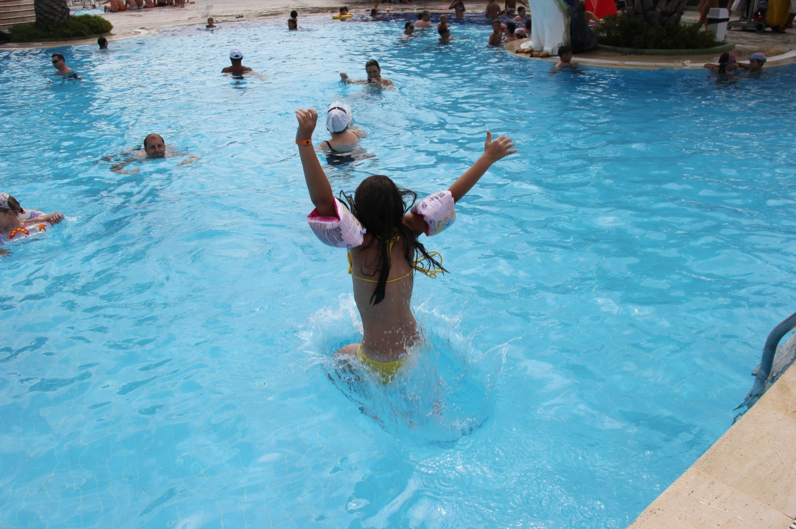
I think swimming is the best activity in summer! There are sports games that we can play in water! A lot of children enjoy them. I like to play water games too.
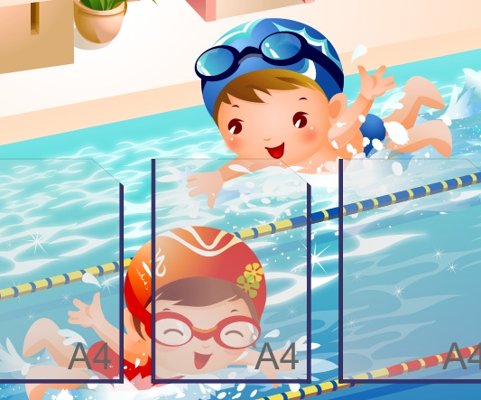

My hobby is rhythmic gymnastics. I adore it!

Rhythmic gymnastics is a sport that combines elements of ballet, gymnastics, dance, and apparatus manipulation.
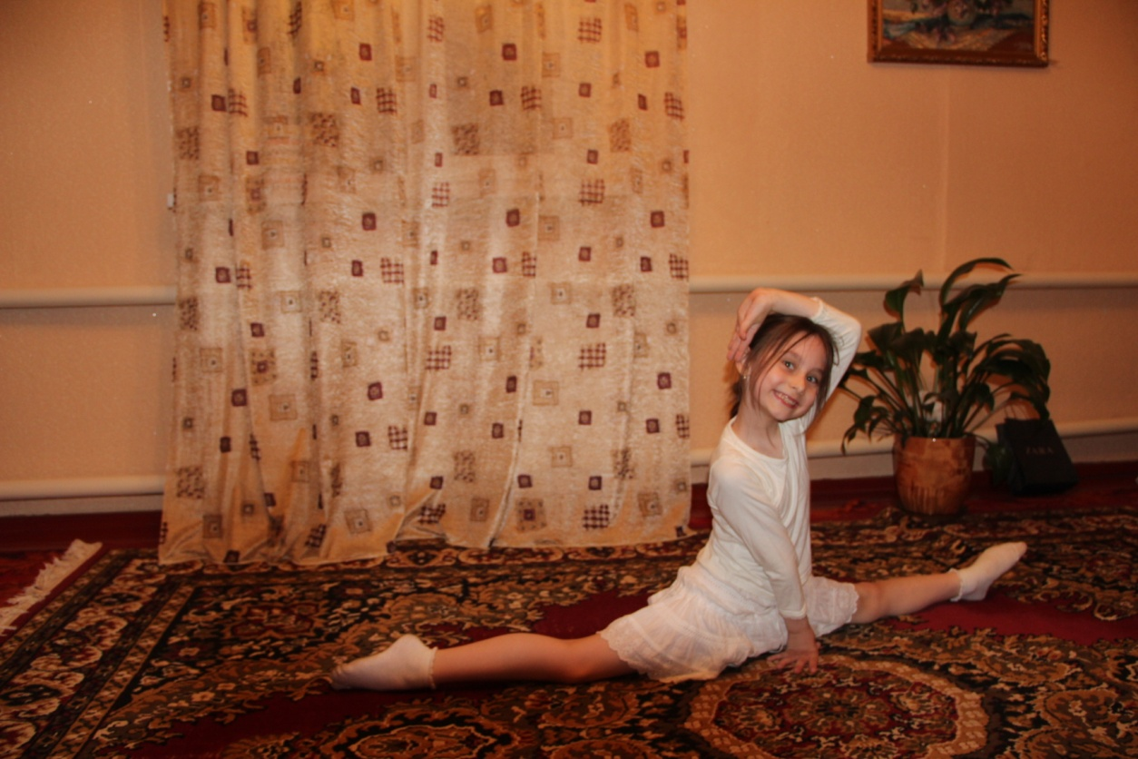
I want to participate in contests and to win! That’s why I train a lot during all the seasons and most of all in summer!
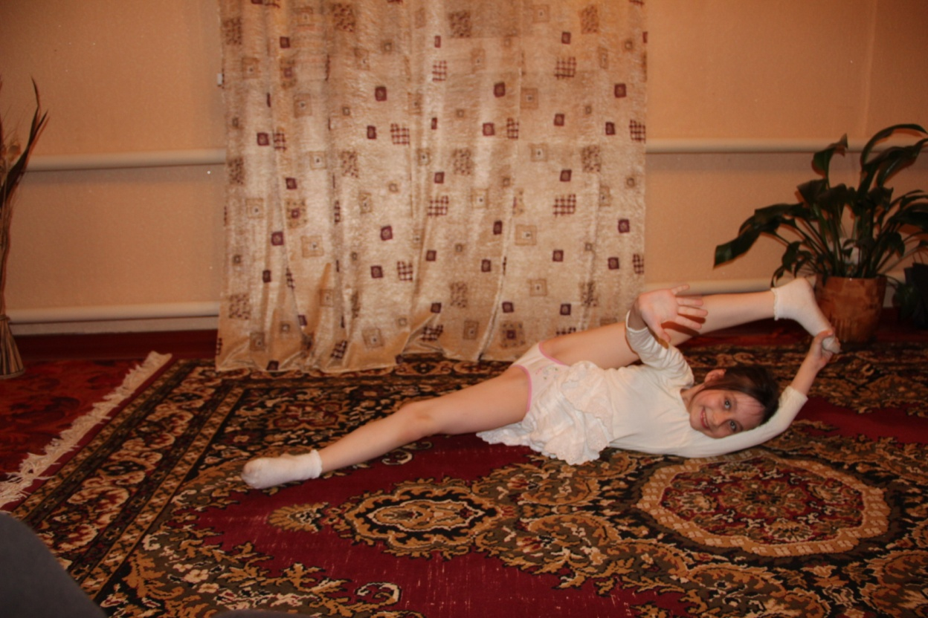

In summer I like to run and jump! It gives me great pleasure!
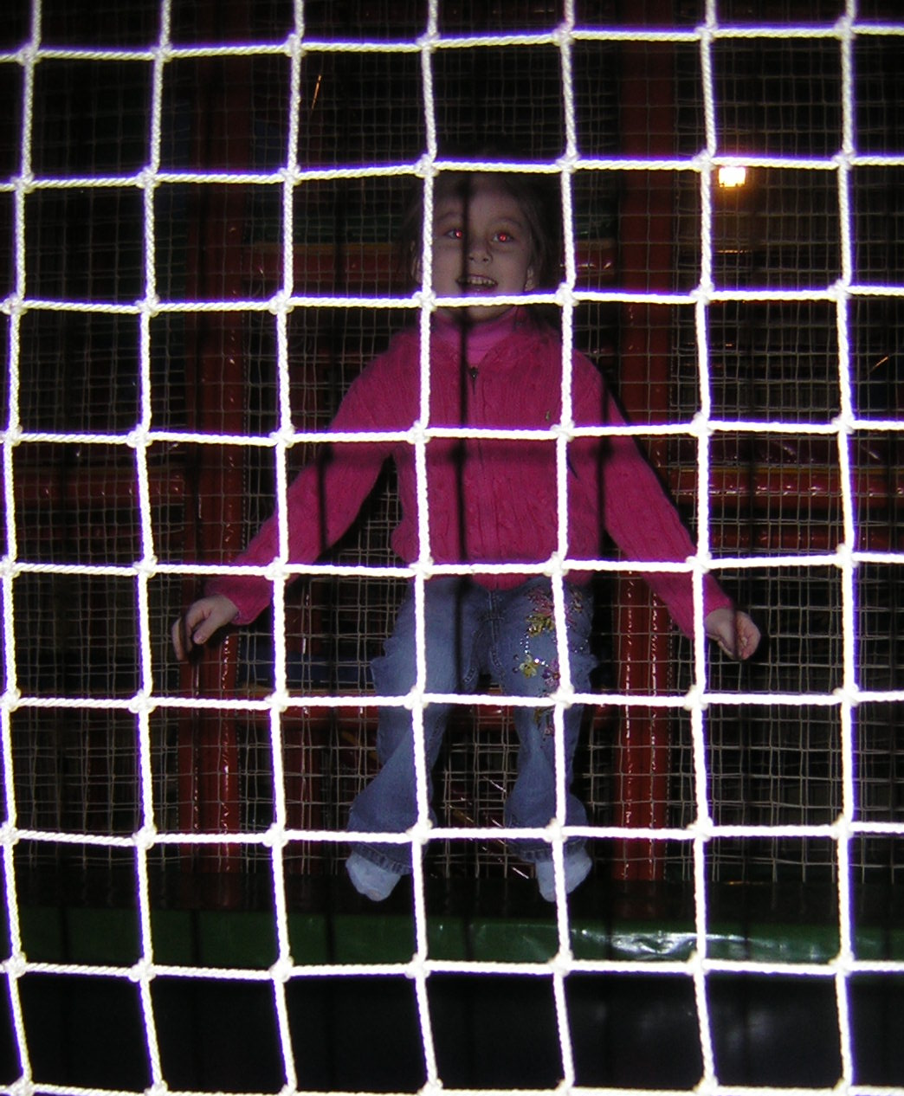
There is one more activity that I’m fond of doing in summer. It is skipping.
Look! I’m skipping well! It’s a lot of fun!

Summer is the best time to play different games. My friends and I prefer playing hopscotch, leapfrog, hide-and seek. It is so exciting!
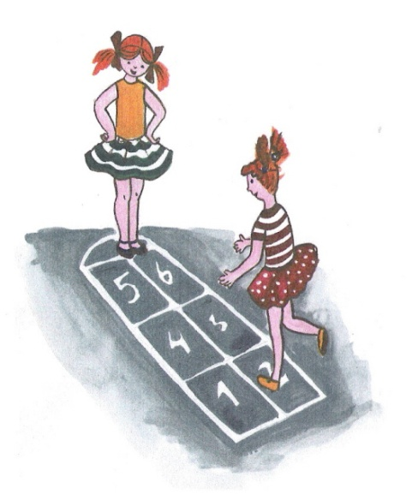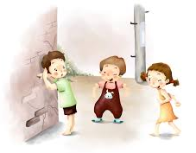
But most of all I enjoy playing with a ball. I often play volleyball, basketball and dodgeball with my friends.
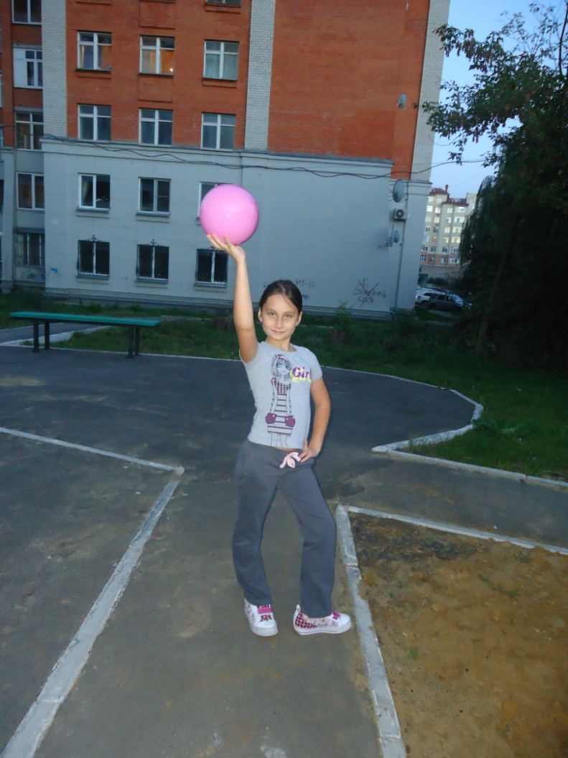

My dream is to learn to play tennis. I am not a good tennis player yet but I can play badminton well!
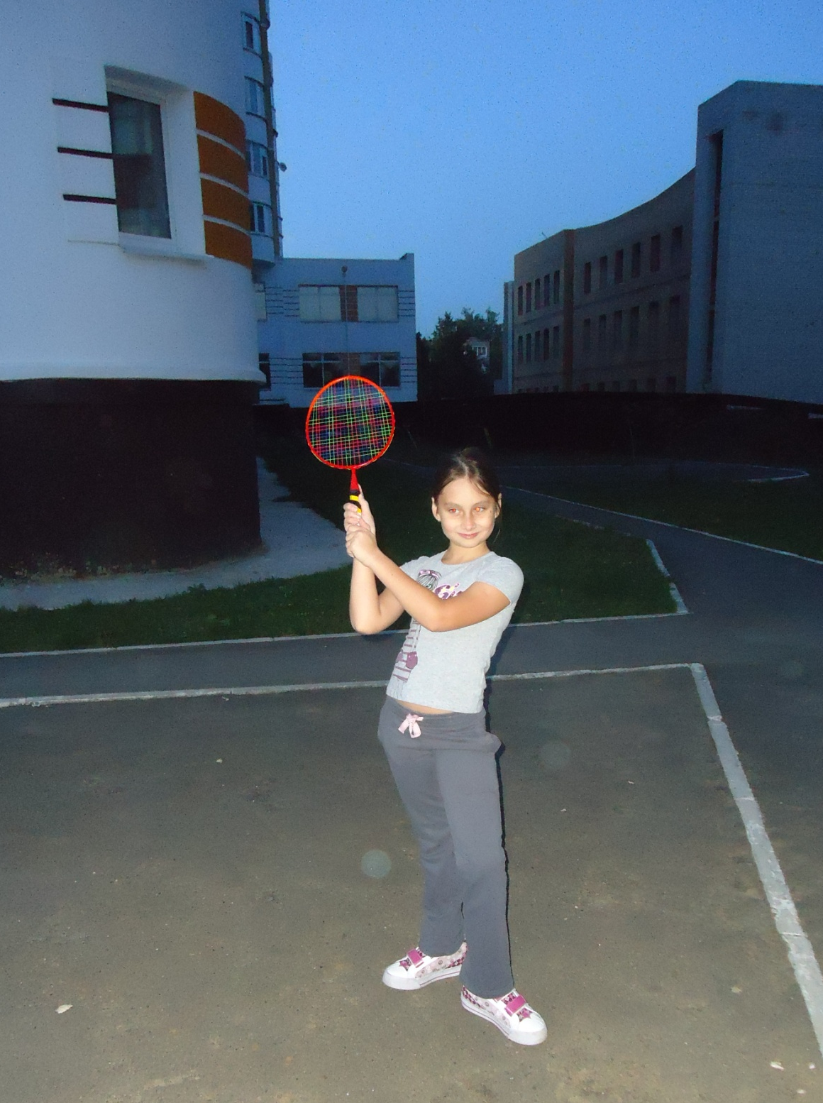

Twisting a hoop is fantastic! I like to do it in my free time!
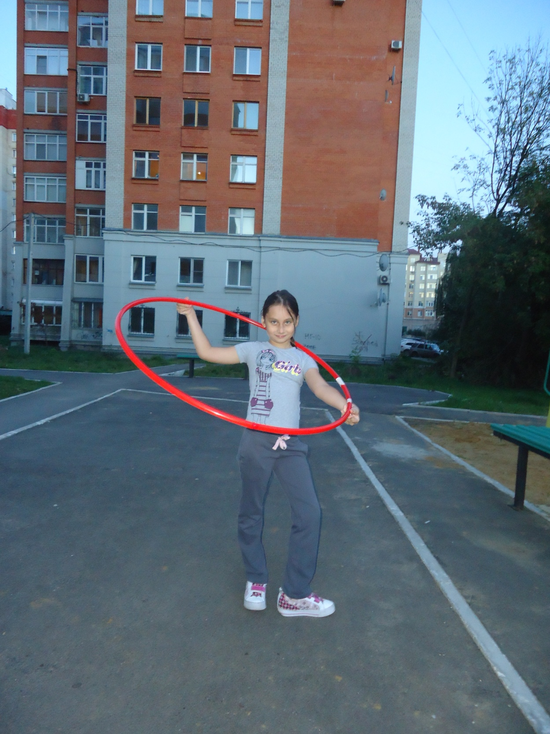
In my opinion, children are happy in summer. They can take part in so many activities that can improve their health. That’s why all we must do morning exercises and play sports games!

В своей работе мною использованы фотографии из личного архива с разрешения родителей, а также изображения, взятые из http://images.yandex.ru/

